Assignment 2 - Python and Bash
- Ubuntu Server update - sudo apt update –y and sudo apt upgrade –y
- Checking Python Version - python3 --version
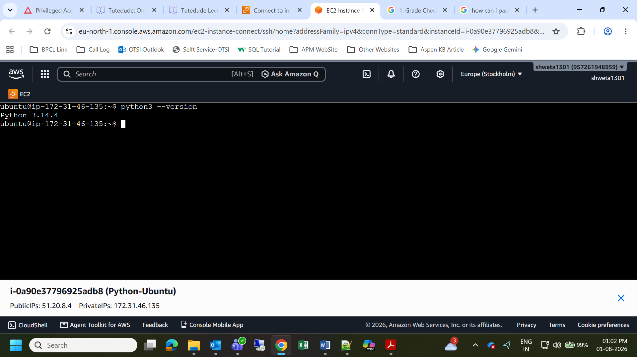
- Create New python File - nano grade_checker.py and paste the below Python Code
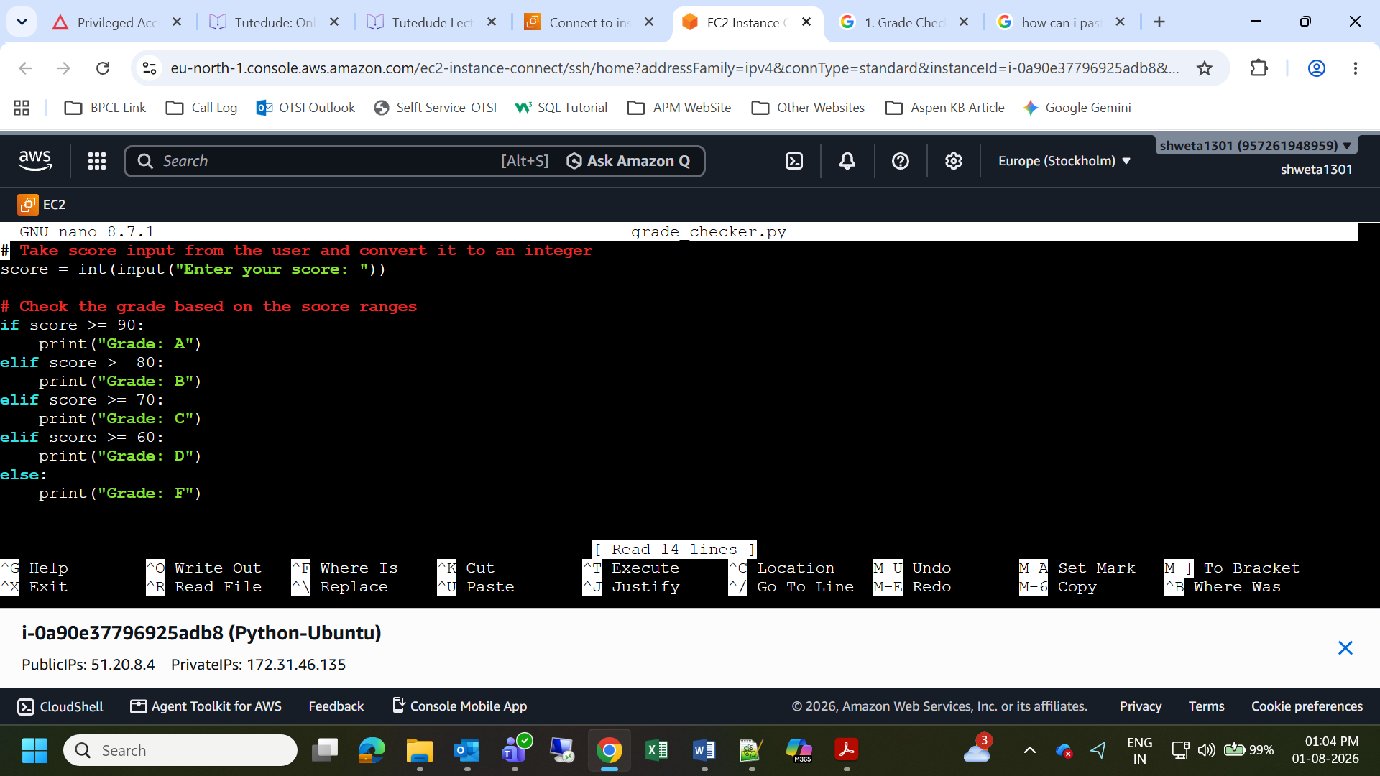

- Copy Grade Checker script
# Take score input from the user and convert it to an integer
score = int(input("Enter your score: "))
# Check the grade based on the score ranges
if score >= 90:
print("Grade: A")
elif score >= 80:
print("Grade: B")
elif score >= 70:
print("Grade: C")
elif score >= 60:
print("Grade: D")
else:
print("Grade: F")
- Ctrl + X, press Y, and then hit Enter
- For Running Output - python3 grade_checker.py
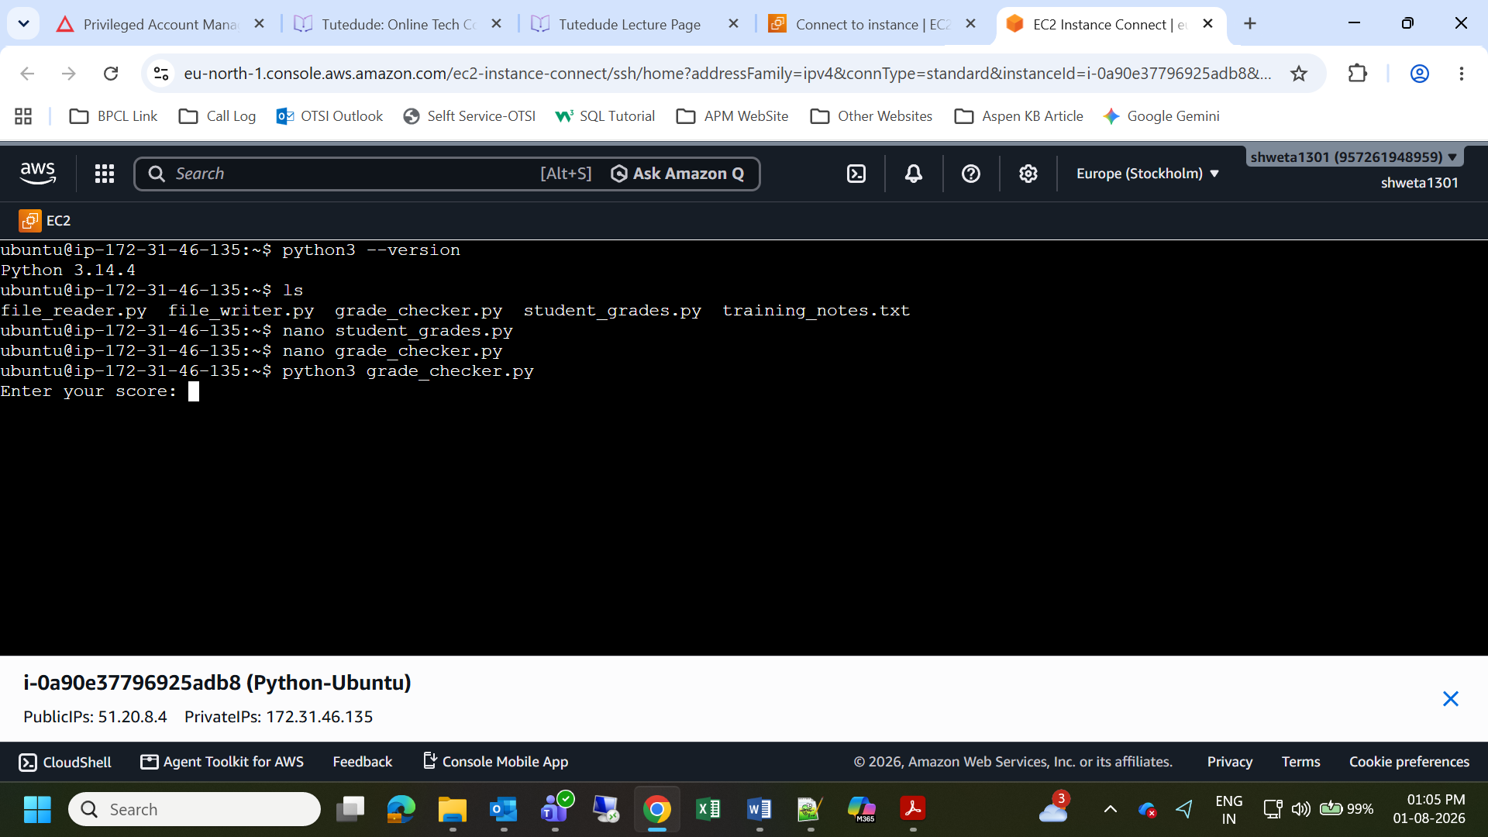
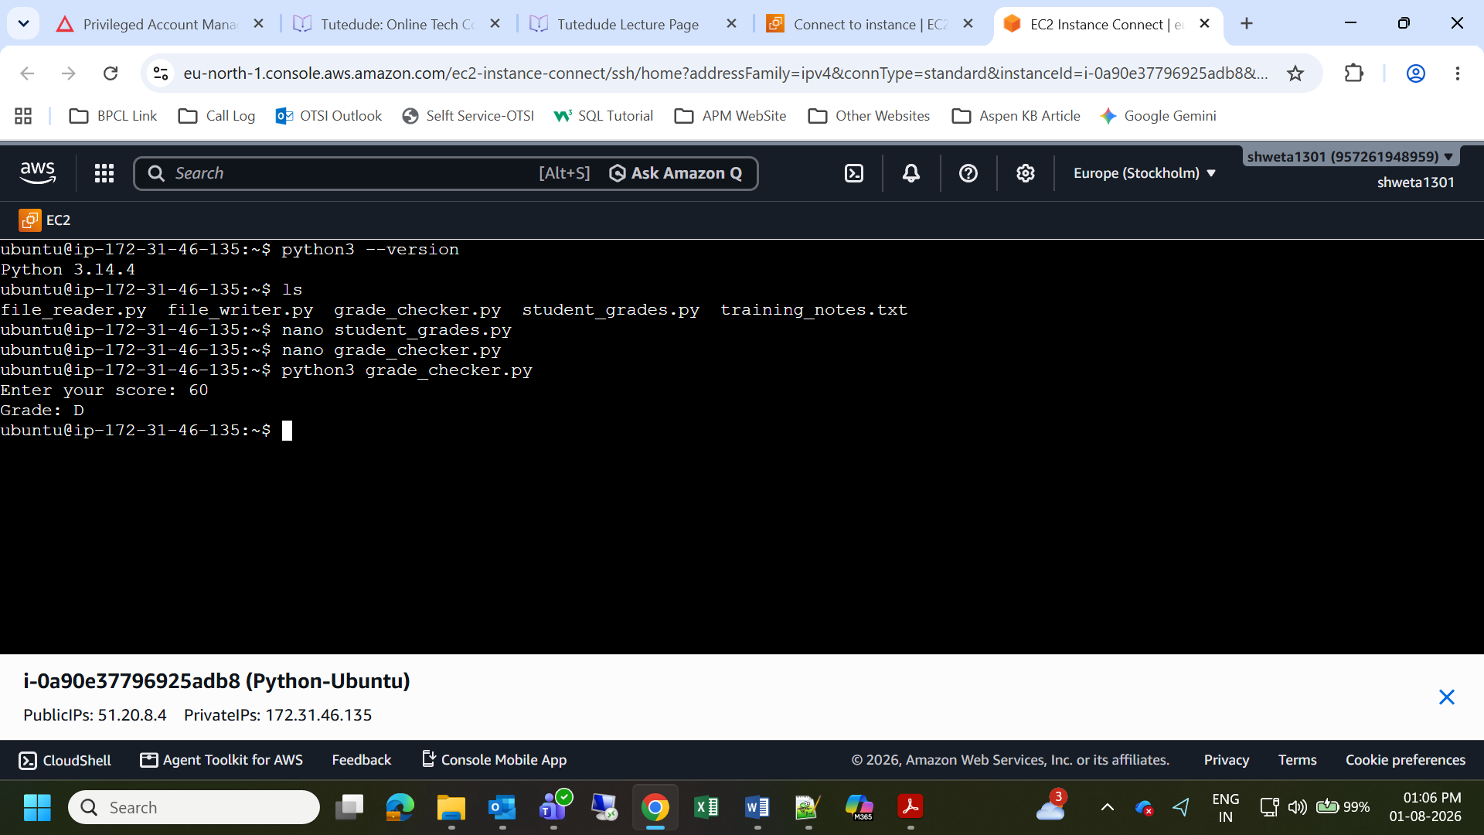
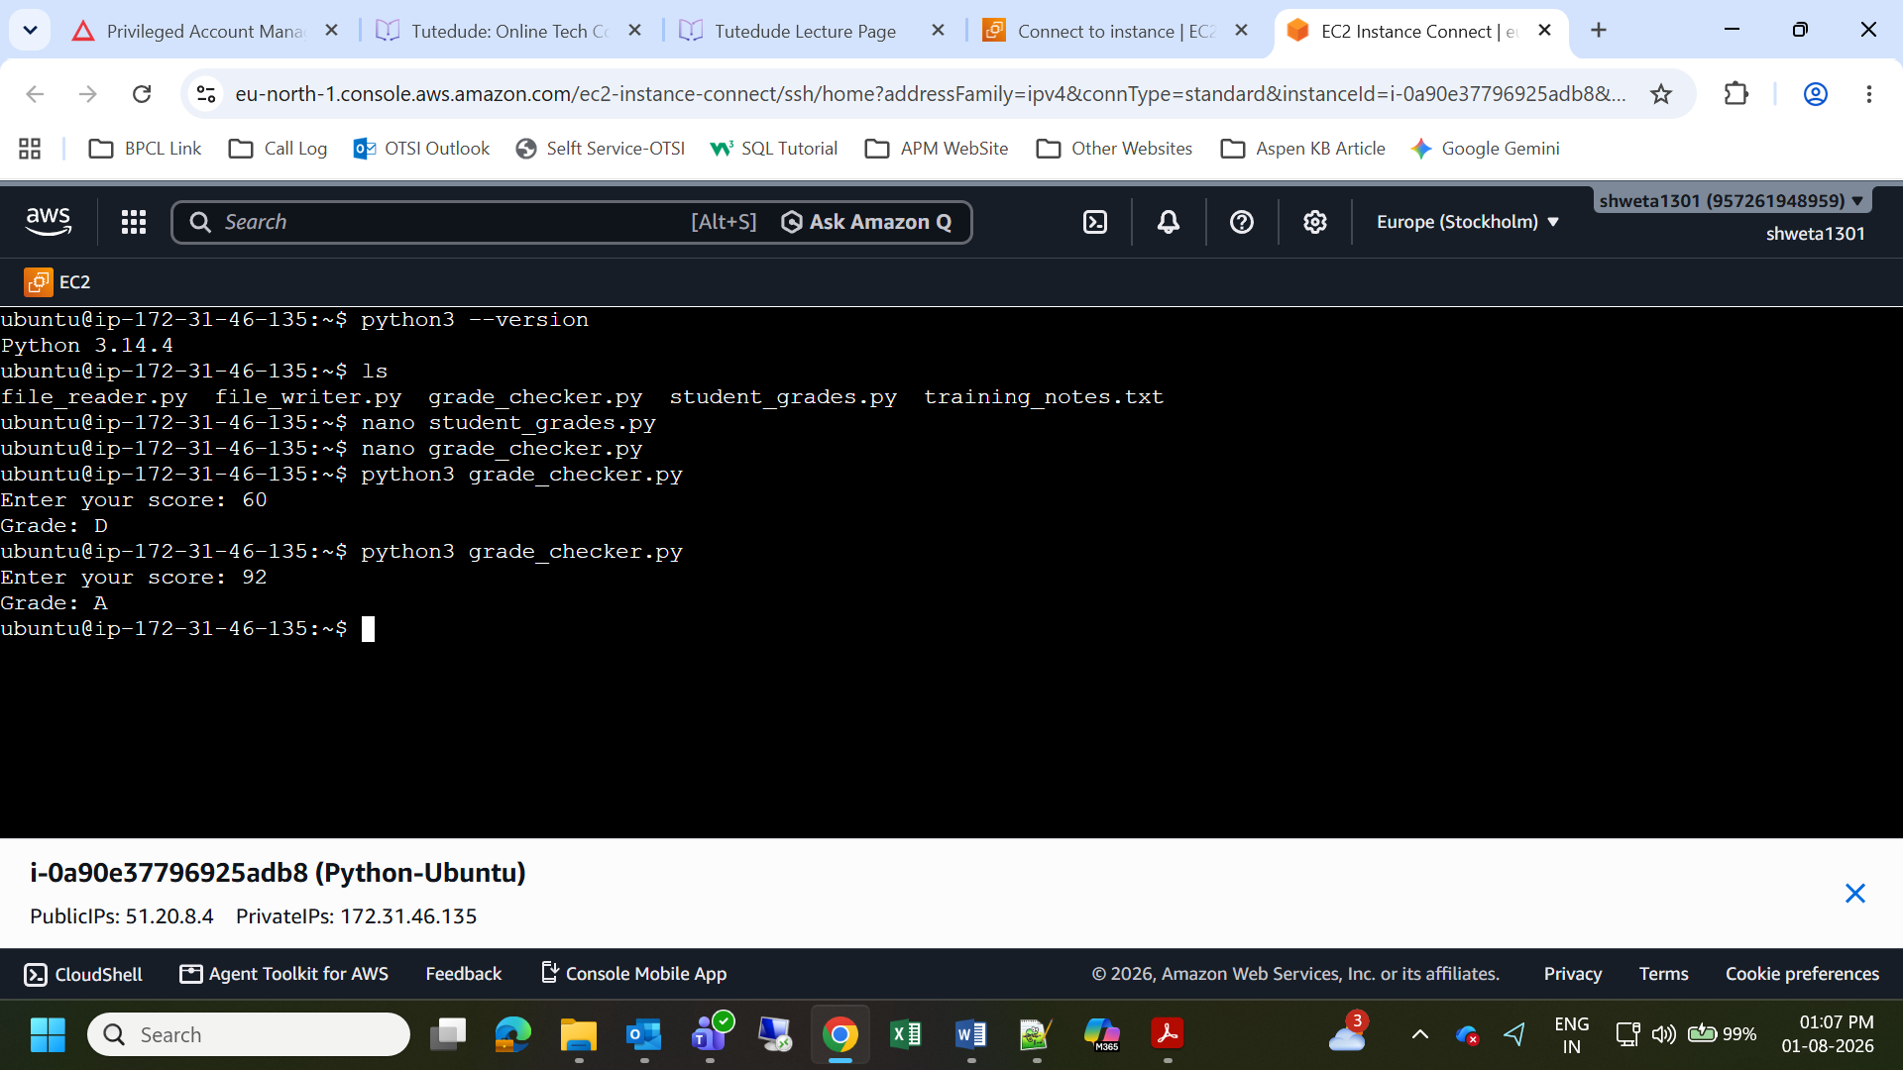

2. Student Grades
- Create New python File - nano student_grades.py and paste the below Python Code
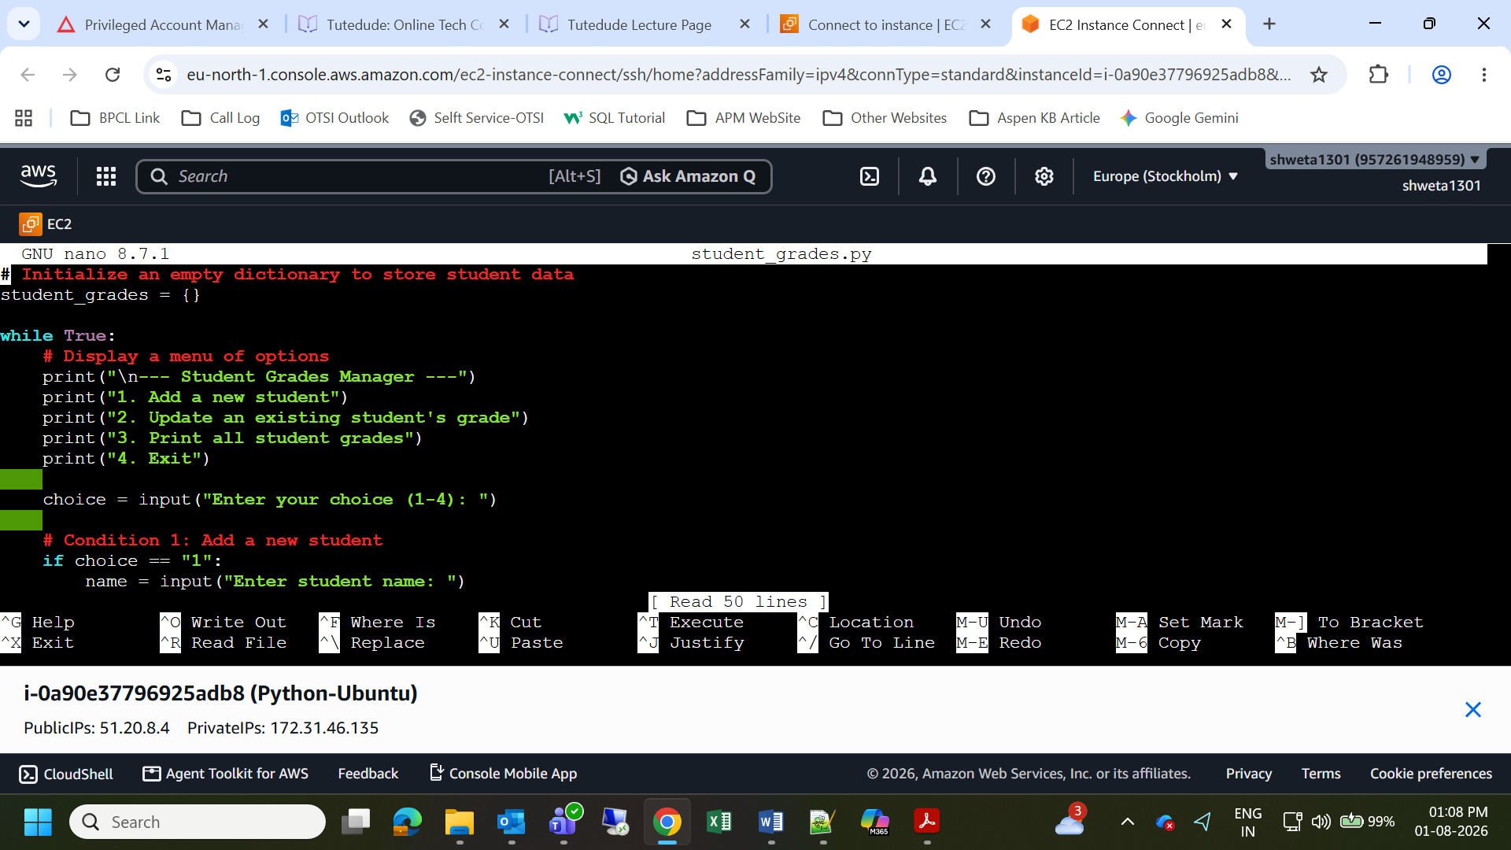

- Copy Grade Checker script
# Initialize an empty dictionary to store student data
student_grades = {}

while True:
# Display a menu of options
print("\n--- Student Grades Manager ---")
print("1. Add a new student")
print("2. Update an existing student's grade")
print("3. Print all student grades")
print("4. Exit")

choice = input("Enter your choice (1-4): ")

# Condition 1: Add a new student
if choice == "1":
name = input("Enter student name: ")
if name in student_grades:
print("Error: Student already exists! Use option 2 to update.")
else:
grade = input("Enter student grade: ")
student_grades[name] = grade
print(f"Success: Added {name} with grade {grade}.")

# Condition 2: Update an existing student
elif choice == "2":
name = input("Enter student name to update: ")
if name in student_grades:
new_grade = input("Enter new grade: ")
student_grades[name] = new_grade
print(f"Success: Updated {name}'s grade to {new_grade}.")
else:
print("Error: Student not found!")

# Condition 3: Print all grades
elif choice == "3":
if not student_grades:
print("The gradebook is currently empty.")
else:
print("\n--- Current Gradebook ---")
for name, grade in student_grades.items():
print(f"{name}: {grade}")

# Condition 4: Exit the program
elif choice == "4":
print("Exiting program. Goodbye!")
break

# Catch invalid menu choices
else:
print("Invalid choice! Please enter a number between 1 and 4.")
- Ctrl + X, press Y, and then hit Enter
- For Running Output - python3 student_grades.py
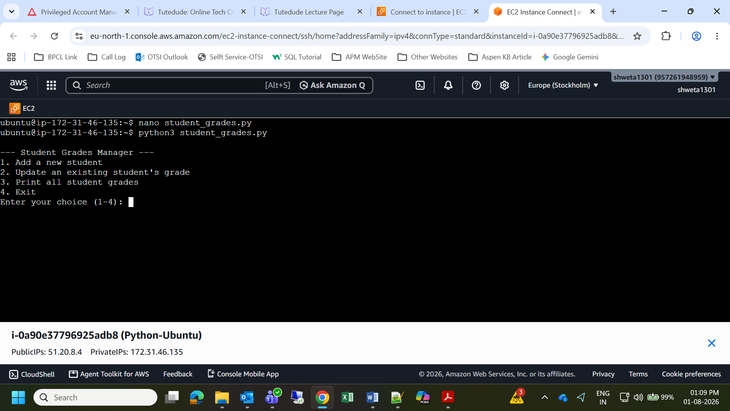
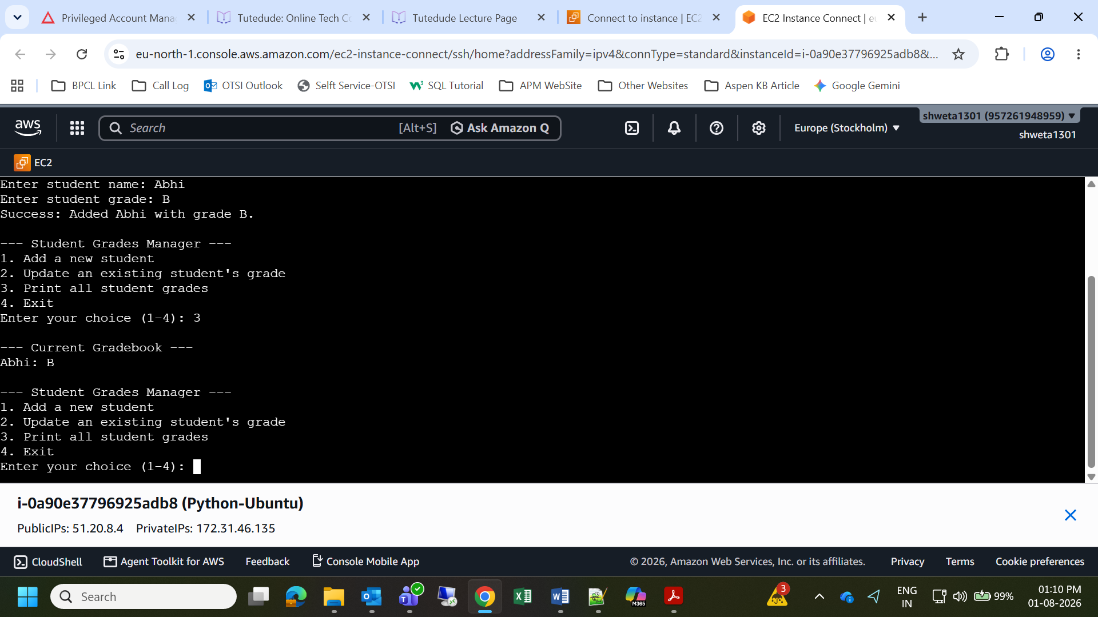
3. Write to a File
- Create New python File - nano file_writer.py and paste the below Python Code
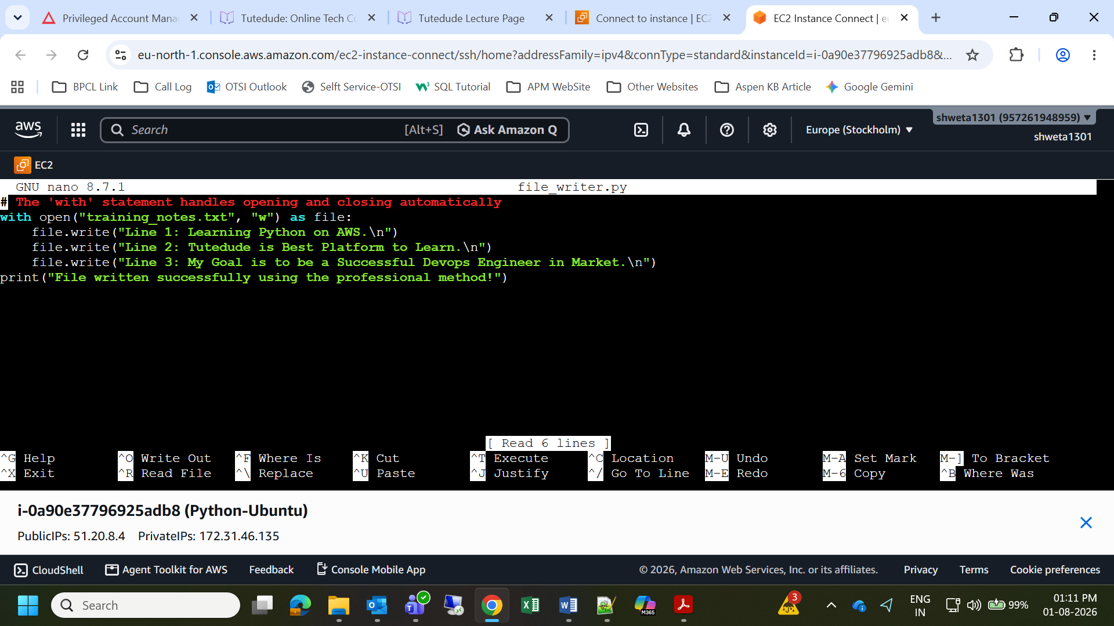
- Copy Grade Checker script
# The 'with' statement handles opening and closing automatically
with open("training_notes.txt", "w") as file:
file.write("Line 1: Learning Python on AWS.\n")
file.write("Line 2: Using the 'with' statement is best practice.\n")

print("File written successfully using the professional method!")
- Ctrl + X, press Y, and then hit Enter

- For Running Output - python3 file_writer.py
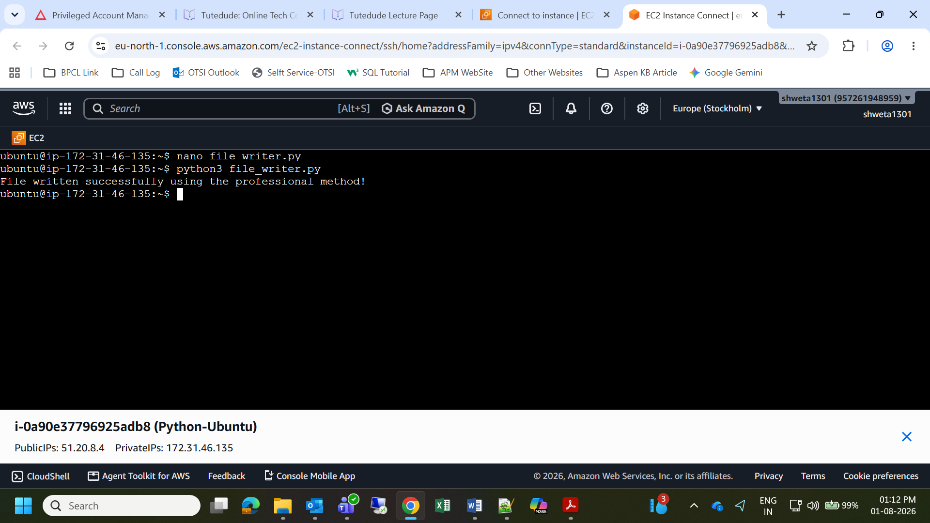
4. Read from a File
- Create New python File - nano file_reader.py and paste the below Python Code
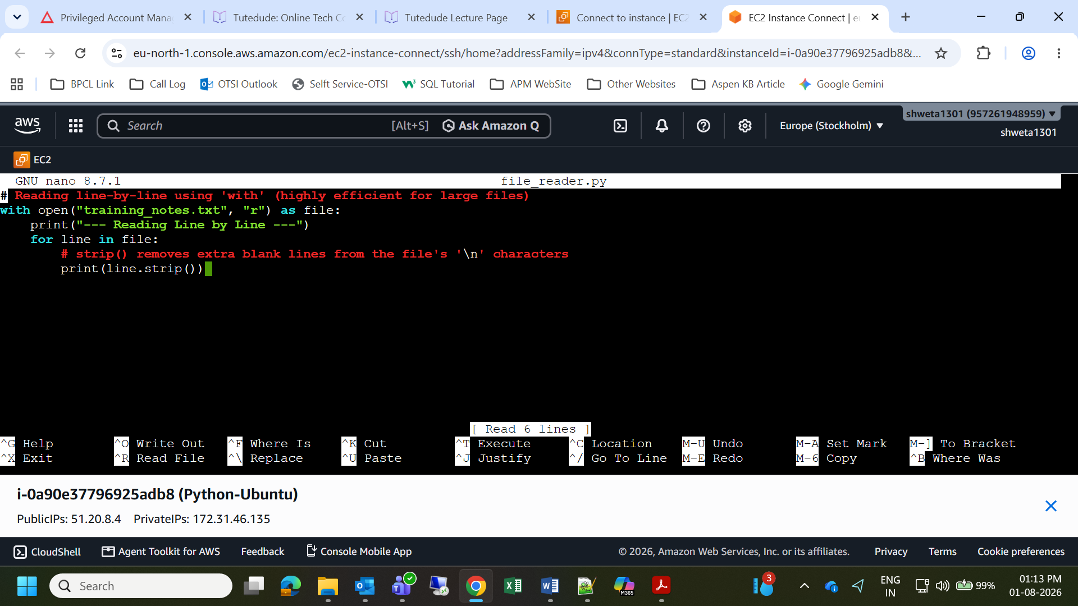

- Copy Grade Checker script
# Reading line-by-line using 'with' (highly efficient for large files)
with open("training_notes.txt", "r") as file:
print("--- Reading Line by Line ---")
for line in file:
# strip() removes extra blank lines from the file's '\n' characters
print(line.strip())
- Ctrl + X, press Y, and then hit Enter
- For Running Output - python3 file_reader.py
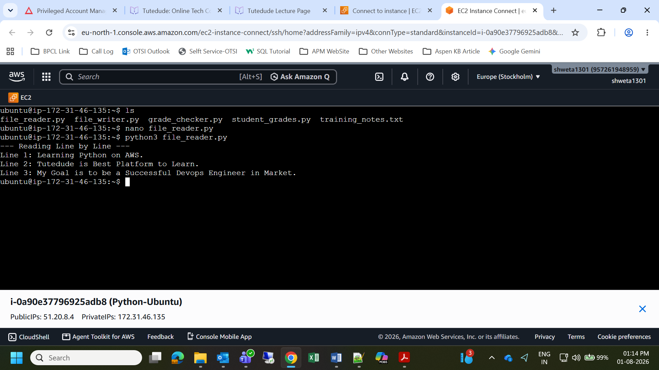

Github Repo - https://github.com/prasannadeploy143/TutrDude-DevOPS-Training-Prasanna

